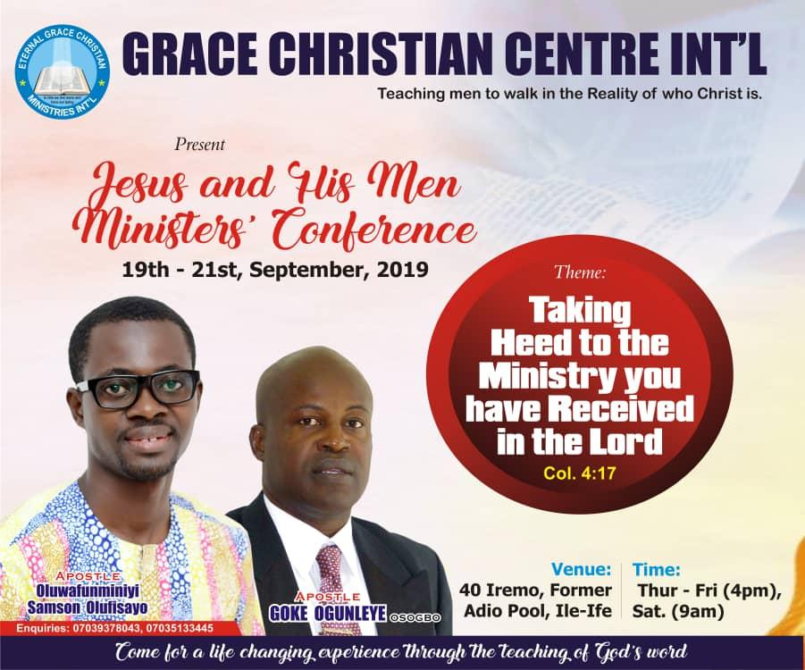

Welcome Address

Beloved servant of the living God, greetings of love in Jesus name. We are so excited to receive every minister and helpers of war of the Gospel of our Lord Jesus Christ at this edition of Jesus and His Men Conference 2019 with the theme : Taking Heed To The Ministry You Have Received In The Lord. Ministry is an assignment / mandate that only God can handle but is entrusted to man to accomplish, such man must always look up to God in order to fulfill it. Ministry is not doing something for God as you wish, but it is God working through a man on this side of heaven what He has ordained in the spirit for His glory Heb 8 : 5.

Mark 3: 13 - Every genuine ministry begin with a call. Ministry is not done by the prerogative of the minister but it is done by God's initiative. A call always receive ministry. People who do not have understanding that they have been called cannot do ministry effectively. How Do we execute ministry in this light? According to our anchor scripture, col 4:17, we must know by revelation that we have been called by God-heb5 :
4 - why must we know? Because it is the beginning of a genuine ministry. Ministry is standing on the consciousness that God call you :it is not that you assume something, but doing what God actually call you to do. The first thing that must happen to the
person who is called by God is the revelation of God’s call upon his/her life. That
revelation must be there so that you can know that you are accountable to God, you are empowered by Him and you can do it as He will.

Act 20 : 28- you cannot take heed to the ministry you have received if you have not first take heed to yourself, because you are the ministry that eternity is counting on! Your stand and growth determines the effectiveness or how far the work will go. Take heed to yourself means pay close attention. A minister of the Gospel must first guard himself before he can oversee the flock adequately. How well you function and fulfill the ministry you have received from the Lord as a lot to do with your understanding. It is a great foundation upon which how meaningful your life and ministry turns out to be. The priority of ministry is not service. It is intimacy with God. Service is actually a product of ministry. Mark3 : 13 - the scripture says He called the twelve to be with Him; what was His goal? To send them out to go and preach. What was His priority? It is intimacy! Intimacy with the one who Has called you. Why is it that important? If you don't really know Him as you ought to know Him, you can’t serve Him acceptably. You can’t serve Him the way He wants to be served and you cannot do ministry effectively.

To fulfill the ministry, you must give your totality to the call. You must be ready to put in all it takes or demands to please Him. Luke14:26-33,-A Minister must be ready to forsake all and bear his cross. It takes whole hearted commitment.

As we have come and learn at the Lord's feet in these three days meeting, stay tune to the Holy spirit; I strongly believe God will do great and mighty things in our lives and ministries, there will be divine alignment in our assignment, He will stir up every divine deposits in the womb of our calling and impartations that will enable us to be more effective in the area of our Grace and calling and to promote unity in the body of Christ.

Word from the Lord for Ministers on the 15th of September 2019.
NOTES

NOTES
There is a God who seems to hold you down. Sometimes He does that so that He can aim you aright.

There is a God who seems to have no plan or good intention for you at all. Sometime He does that so that He can aim you to go far. He does that knowing He is doing you good.

Once again,

You are welcome

Yours in Christ,

Apostle & Rev Mrs O. OLUFISAYO.

MINISTERS’ PROFILE
Apostle Goke Ogunleye is a New Testament minister. He is the president of Alleluia to Jesus Ministries, the General overseer of Jesus faith Christian chapel. He serves as a life coach, trainer and covering to many ministers is in the body of Christ. He hold a weekly programme tagged faith trumpet church on air and other outreaches such as believer faith seminar which holds Bi-monthly.

He is a missionary by calling, teaching and preaching majorly on faith and redemption. His apostolic, prophet and teaching ministry has greatly impacted people live. His wife Rev. Mrs Subomi Ogunleye works together with him in ministry and they are blessed with three children. They reside in Osogbo, Osun State, Nigeria.

Apostle Oluwafunminiyi Samson Olufisayois an ordained minister of the gospel called and sent from God as a conference speaker and life trainer with an apostolic teaching and preaching mandate to teach men to walk in the reality of who Christ is. He is also passionate about seeing the order of God being established in the Church. His apostolic teaching has influenced, Inspired and transformed many lives in this Era.
He is the President of Eternal Grace Christian Ministries International and the set man of Grace
Christian Centre International.
He holds an Annual meeting tagged GATHERING OF THE EAGLES, and a quarterly programme tagged YOUTH DESTINY SUMMIT, REVELATION OF OUR SALVATION, and also an annual Conference meeting for Ministers tagged: JESUS AND HIS MEN CONFERENCE [JAHMEC]. He also hold a Teaching School-ACQUIRING MINISTERS’ TEACHING SCHOOL (AMITES) for those who have perceive the Call of God and those who are involving in church work. All these are set to teach and impact men to align with the ultimate counsel of God for their lives. He is happily married to Rev.Olamide Deborah Olufisayo who also serves with him in Ministry. They reside in Ile-Ife,Osun State, Nigeria.

Schedule of Ministration

Date And  Days | Morning Session | Evening Session
19 TH SEPT. THURSDAY |  | Apostle Oluwafunminiyi S. Olufisayo
20 TH SEPT. FRIDAY |  | Apostle Goke  OGUNLEYE
21 ST SEPT. SATURDAY | Apostle Goke  OGUNLEYE | DEPARTURE

Programme of events
Thursday 19th September 2019 Evening
4: pm - 4:10p.m. [10 mins.] Opening Prayers
4:10pm –4:35 p.m. [25 mins] shout of Praise
4:35pm – 5 p.m. [25 mins] Prayers and Supplication
5 pm – 5:10 p.m .[10 mins.] Introduction of The Minister
5:10 – 5:25 p.m. [15 mins.] Choir Ministration
5:25 – 7:25 p.m. [2 hrs] Word Ministration
Apostle.OluwafunminiyiS.Olufisayo
7:25 – 7:35 p.m. [10 mins.] Offering and announcements.
Friday 20th September 2019 Evening
Saturday 21st September 2019 Morning
9am – 9:10a.m. [10 mins.] Opening Prayers
9:10 –9:40 a.m. [30 mins] shout of Praise
9:10 – 9:35 a.m. [25 mins] Prayers and Supplication
9:35 – 9:45 a.m .[10 mins.] Introduction of The Minister
9:45 – 10:00 a.m. [15 mins.] ChoirMinistration
10:00 – 12:30 p.m. [2hrs 30mins] WorMinistration
Apostle. Apostle.Goke OGUNLEYE
12:30 – 12:45 p.m. [15 mins.] Offering and announcements.

ANNOUNCEMENTS
Grace Christian Centre International is a place you need to always be for your divine training for life and destiny.
WORSHIP WITH US
Sunday Sunday service 8am-12pm Tuesday school of prayer 5pm-6:30pm Thursday Revelational Hour 5pm-7:30pm
The church operates a ministry Arm (Eternal Grace Christian Ministry
International) and s our programme for the 2019 is stated below:
❖ Encountering the God of Possibility
Day: Every last two days of the month and first day of the other month
Time: 5pm
❖ AMITES Batch B (In Progress)
• For the fivefold ministry,
• Those who work in the church, and
• Those that perceive the call of God upon their lives.
December 2019
❖ Annual Gathering of the Eagles(AGOTE)
❖
✓ For counseling and prayer with God’s servant.
Date: Tuesday

4:pm - 4:10p.m. [10 mins.] Opening Prayers
4:10pm –4:35 p.m. [25 mins] shout of Praise
4:35pm – 5 p.m. [25 mins] Prayers and Supplication
5 pm – 5:10 p.m .[10 mins.] Introduction of The Minister
5:10 – 5:25 p.m. [15 mins.] Choir Ministration
5:25 – 7:25 p.m. [2 hrs] Word Ministration
Apostle.Goke OGUNLEYE
7:25 – 7:35 p.m. [10 mins.] Offering and announcements.
Time : 11:00am – 2:00pm.
Call: 08086496427,07062709694.
AVAILABLE MESSAGES
• Cultivating the habit of seeking and receiving divine help in the time of need.
• The law of going little further
• Understanding prayer and the hindrances that chokes its effectiveness
• Conflict in marriage and how deal with it
• The law of conditioning
• Marriage, do you understand what you are about to get into or what you are
already into.(Series).
• Developing a strong Spirit

